Trent Giever

Ch 12 Access Management

Project 12-1

7/31/18

Project 12-1 Using Windows Local Group Policy Editor

12-1-7

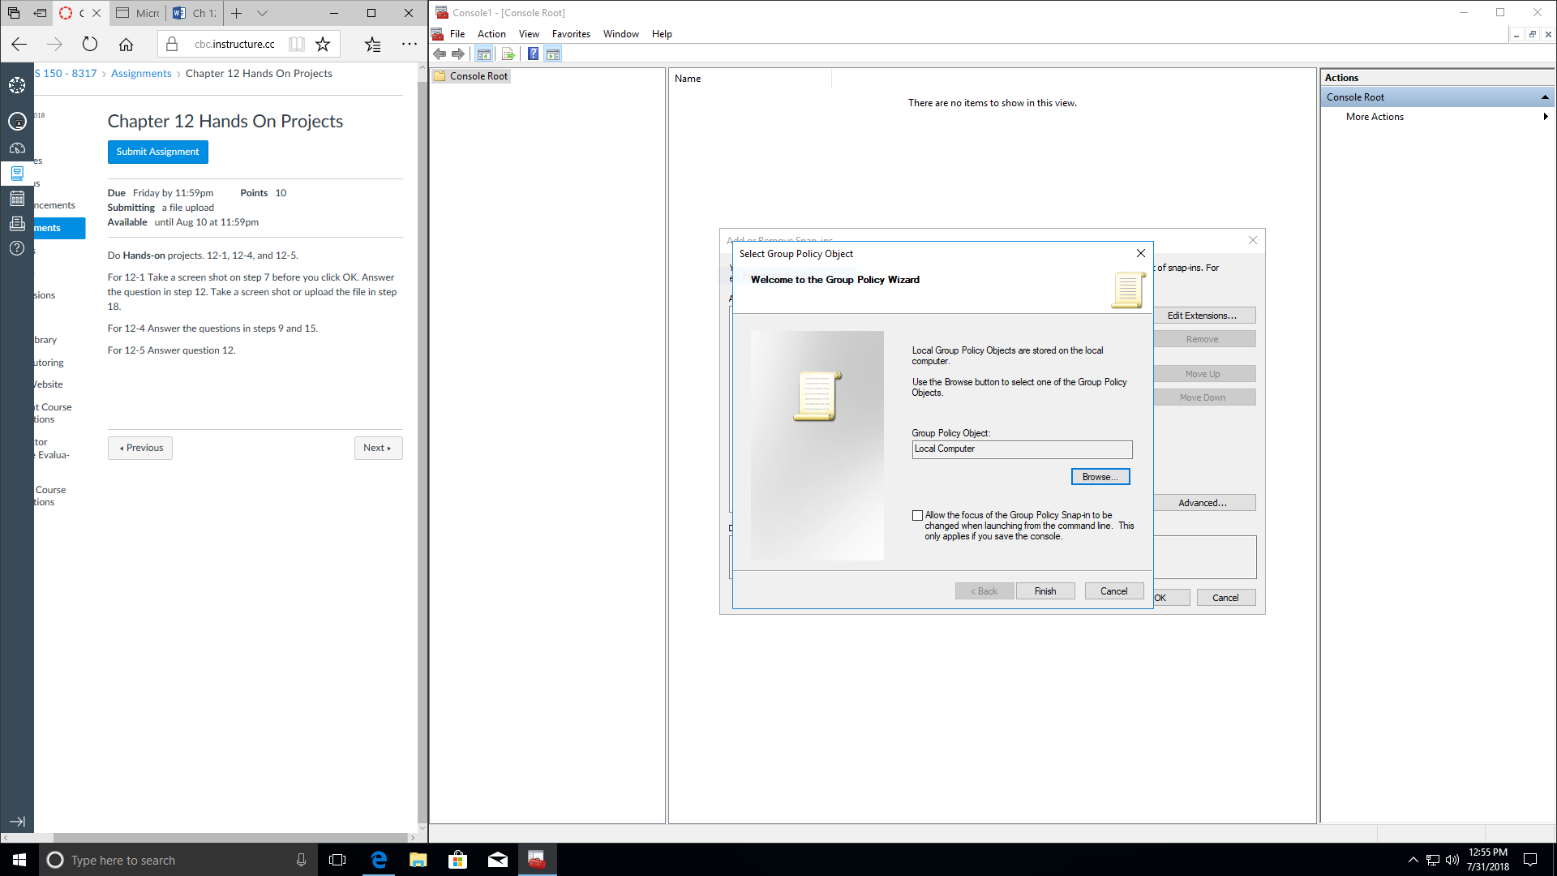

12-1-12

Which settings can you identify that directly relate to security?

All 2355 settings all relate to security from which types of files and programs (like Java based) can be opened or denied. Also can deny or allow ports and cds to be used. Some of the other features is the system settings that most users will not care about, but are important like which ports to block, and accept traffic from.

Project 12-4 Exploring User Account Control

12-4-9

What Happens?

After changing from anything needs a popup to the opposite caused no warnings to happen and the program opened up with no troubles.

12-4-15

What Happens?

The only setting that does not get the popup is the never notify setting. So it gets the same popup before being allowed to continue.

12-5 Exploring user control part 2

12-5-12

What is different about your desktop now?

By switching the disabled setting the UAC switched to the don’t notify me of anything level on its own. I even tested it with both windows open and switched to disabled and UAC saw it drop to a lowest level.